TSO School Day Concert

Peter
And
The Wolf

October 24, 2023
Topeka Symphony Orchestra
Conducted by Kyle Wiley Pickett
THE MAIN IDEA:
This year’s School Day Concert will be feature music about animals. The pieces are: Peter and the Wolf, the Waltzing Cat, and How to Train Your Dragon. Our own conductor, Maestro Kyle, will narrate the concert.

Orchestral music …..
is music written for an orchestra, which is a group that usually includes strings, woodwinds, brass, and percussion instruments. An orchestra is led by a conductor, who uses his or her baton to guide the musicians through the music.
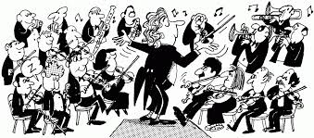

Orchestral music includes a wide range of sub-categories, including “classical” and “romantic” styles. This refers to music written for orchestra from the eighteenth century up through the early part of the twentieth century. (Think Mozart and Beethoven). 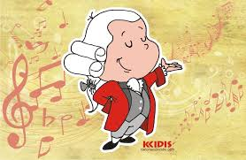

The pieces we’ll be playing at this concert are:

Prokofiev – Peter and the Wolf
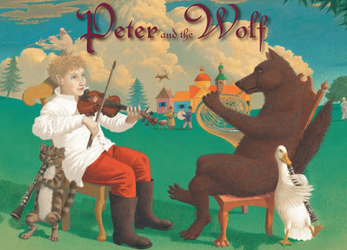
https://www.youtube.com/watch?v=w2QIzHA3hVE

Prokofiev was a master at using music to tell a story. He was commissioned to write Peter and the Wolf by his friend who was the director of the Moscow Musical Theater for Children. This short composition was written as a way to introduce children to the orchestra. The music focuses on singular instruments instead of entire orchestra sections. Prokofiev chose instruments from four instrument families to illustrate his story: strings, woodwinds, brass, and percussion. The bird is represented by a flute, the duck by an oboe, the cat by a clarinet, the grandfather by a bassoon, the wolf by French horns (three of them!), Peter by the strings (violin, viola, cello, and bass), and the hunters by the timpani. Each character has its own theme music.
Leroy Anderson – The Waltzing Cat
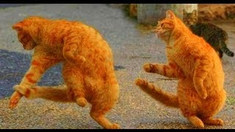
https://www.youtube.com/watch?v=DOlG8Ut-gTc
Composed in 1950, Leroy Anderson’s light orchestral piece The Waltzing Cat is among a collection of his most charming works. The Boston Pops Orchestra performed the piece first as part of a recording that Anderson had set up in September 1950. In the program notes for The Waltzing Cat Anderson writes:
“For the last number on this program you will hear ‘The Waltzing Cat’. If, as you listen to the music, you imagine something like Puss in Boots at a fancy dress ball, that is just about what I had in mind.”
As with many of Anderson’s short light orchestral works, there is a fully-realised character throughout the piece. Anderson’s extensive use of percussion is also a highlight of the piece, especially in the central section that sees whistle slides, wood blocks and triangles used.
John Powell – How to Train Your Dragon
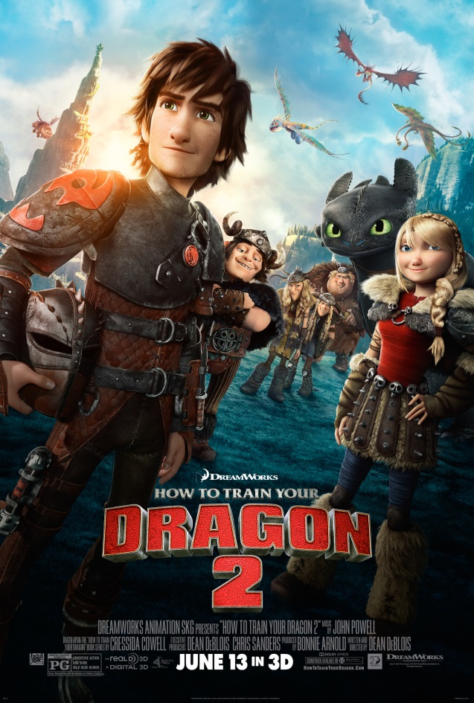
https://www.youtube.com/watch?v=vfU_Wi9mK2k
Hiccup is a Norse teenager from the island of Berk, where fighting dragons is a way of life. His progressive views and weird sense of humor make him a misfit, despite the fact that his father is chief of the clan. Tossed into dragon-fighting school, he endeavors to prove himself as a true Viking, but when he befriends an injured dragon he names Toothless, he has the chance to plot a new course for his people's future.

John Powell‘s versatile score, marked by Scottish musical color, accompanies the adventures of Hiccup and Toothless with strong musical themes. Powell masterfully weaves these into thunderous action, flaring romance, and lighthearted humor, resulting in a stirring, large-orchestral score.
Who is the CONDUCTOR for today’s concert?

Kyle Wiley Pickett is the conductor for the Topeka Symphony Orchestra. Kyle travels all around to different states and even different countries to conduct orchestras. He has conducted in Missouri, California, Montana, Alaska, Oregon, Washington, Kansas, Pennsylvania, Maryland, and Washington, D.C., as well as Mexico, the Czech Republic, and Thailand. He conducts orchestras, operas, musical theatre, and ballet. He studied conducting at the Peabody Conservatory of Music under world-renowned Maestro Frederik Prausnitz.
Maestro Pickett played flute and piano when he was growing up. His mother was a piano teacher, so there was always music in his home. His favorite composers are Brahms, Mahler, and Wagner. He also loves the music from movies like Star Wars, Harry Potter, The Lord of the Rings, and How to Train Your Dragon.
Maestro Pickett uses his free time to go boating and waterskiing with his family and he loves Astronomy and photographing the night sky.

